Questions and answers from the lecture slides for completeness:

1. An axial turbine rotor speed is 12000 rpm, mean radius of the blade is 0.2 m, and the height of the blade is 0.01 m. Calculate the blade speed, U. Given the mass rate is 1 kg/s of air of density 0.8 kg/m3, calculate the axial velocity. Given tangential velocity changes from 200 m/s to 61 m/s, calculate the Euler work rate and hence, assuming air to be a perfect gas, with cp = 1.005 kJ⋅kg-1⋅K-1, calculate the temperature change of the air.

[ans: 251 m/s, 99.5 m/s, 34.9 kW, -35°C]

Solution:

Step 1 is to acquire the rotational velocity of the blade at radius 0.01 m and 12000 rpm.

12000 rpm is 12000/60 = 200 rps

Therefore the velocity at the circumference with radius 0.2 m is 2π×200×0.2 = 251 m/s

That is the blade speed at the mean radius, usually indicated as U.

Axial velocity is cx, by which the x-direction is intended as the axis direction of the turbomachine.

The formula for mass flow rate is $\dot{m}=ρA_{x}c_{x}$ where Ax indicates the flow cross sectional area perpendicular to the axial direction, x. Therefore we need Ax.

Ax = 2πr­­­­mH where H is the blade height or Ax = π(r­­­­m + H/2)2 - π(r­­­­m – H/2)2. The first produces 0.01257 m2 and the second produces 0.01257 m2.

Therefore rearranging the mass rate equation for cx,

The next part of the question wants the Euler work, which is from the formula:

$$\dot{W}=\dot{m}(U_{2}c_{θ2}-U_{1}c_{θ1})$$

This is a turbine, and we are not told the vector direction of the tangential velocities. Actually for a turbine it is usual for the tangential direction to be reversed, since a strong turn is possible due to the robust flow characteristics when expanding, therefore we have to assume that cθ2 is -ve and cθ1 is +ve, and so, using the blade speed calculated above, this should be:

$$\dot{W}=251\left(-61-200\right)=-65511 W or-65.5 kW$$

Work out of the gas, and therefore negative work because it’s a turbine.

If we had assumed that the turbine outlet velocity was still positive then this would be:

$$\dot{W}=251\left(61-200\right)=-34889 W or-34.9 kW$$

Finally, the temperature of the gas going out will be affected by the First Law effect – the gas loses energy by the work process. This is expressed by the steady flow energy equation as usual:

$$\dot{W}+\dot{Q}=\dot{m}∆h→\dot{W}=\dot{m}c_{p}∆T→-65.5=1×1.005×∆T→∆T=-65.2℃$$

Using the -34.9 kW, this would be -34.7°C.

1. A flow in a turbine has cx = 50 m/s, swirl angle α = 30° and cθ = 97 m/s. Calculate cr and cm and c.

[ans: 160 m/s, 168 m/s and 193 m/s]

This requires knowing how cx, cθ and cm relate to c. cr cannot be calculated first – we don’t have enough information for it, so we start with cm which is determined by cθ and the swirl angle:

c

cθ

α

cm

cm = cθ/tanα = 97/tan30° = 168 m/s

cr is then similarly calculated from the relationship of the vector cm and cx in the radial plane:

cm

cr

cx

cr =

it’s strongly radial.

Finally, c is from the top vector diagram:

c = $\sqrt{c_{m}^{2}+c_{θ}^{2}}=\sqrt{{168}^{2}+{97}^{2}}=193 m/s$

1. For a turbine rotor row with inlet velocity c1 at 70° and outlet c2 at 20°, use the Zweifel criterion for the blade spacing and determine the blade spacing for turbine blades with chord 40 mm and stagger angle 25°.

[ans: 0.14, 6.2 mm]

The derivation from Zweifel produces $\frac{s}{b}=\frac{0.4}{\cos^{2}α_{2}\left(tanα_{1}+tanα_{2}\right)}$

Simply put in the values. But you must first work out what b is by resolving the chord length in the direction of the axis according to its stagger angle – the angle the chord makes to the axis direction.

Chord length, L

b

Axis line

ξ

b = L sin ξ = 40 cos 25° = 36.3 mm

Then s = 0.4x36.3 / (cos220°(tan70°+ tan20°)) = 5.3 mm

This is very tight. If it is done for the blade angles the other way around, i.e. if the entry to the blade has a swirl angle of 20°and the exit is 70°, the situation is very different, and a much better design, from this point of view at least: s = 0.4x36.3 / (cos270°(tan70°+ tan20°)) = 39.9 mm. Below shows the comparison of the two cases – case 1 on the left and case 2 on the right.

1. A turbine stage has a desired flow coefficient of 0.8, reaction of zero and stage loading of 5.1. Find the entry and exit relative flow angles and sketch the velocity triangles; calculate the axial velocity and given that the blade speed is 100 m/s, calculate the swirl angles, α.

[ans: 72.6°, see next slide, 80 m/s, 62.5°, 77.3°]

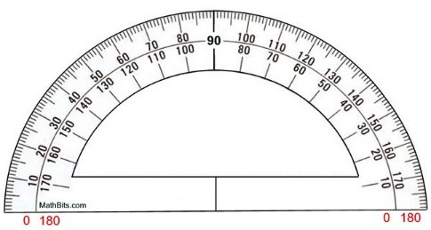Using the given arrangement of formula for the repeating stage design with reaction, R, flow coefficient, φ, and loading coefficient, ψ:

$$tanβ_{3}=\frac{ψ/2+R}{ϕ}→tanβ_{3}=\frac{{5.1}/2+0}{0.8}=3.188, so β_{3}=72.6°$$

Because R = 0, $β_{3}=β_{2}$. To get $α$, it’s useful to draw the diagram to get the values:

c3

w2

w3

c2

α3

α2

Note: the U velocity vector is the other way round compared to the one on the slide, therefore the w vectors converge on the start of the U vector on the RHS here and the c vectors converge on the LHS.

The axial velocity, cx is from the flow coefficient formula $∅=\frac{c_{x}}{U}$, and putting the values of φ = 0.8 and U = 100 m/s produces cx = 80 m/s. The swirl angles, indicated as $α$, some manipulation of the geometrical trigonometry is required. We need to find the angles indicated by dashed angle lines, and we must use the velocity vector opposite the angle, which is c2θ for α2, and w3θ for α3, and the velocity vector adjacent to the angle, cx. We can calculate w2 from cx and β2 as w2θ = cx tan β2 = 80 tan 72.6° = 255.3 m/s, and then c2θ = w2θ - U = 255.3 – 100 = 155.3 m/s. Then α2 = tan-1 (155.3/100) = 57.2°.

Similarly, w3θ = w2θ because it’s zero reaction means w3 = w2 and they are at the same angle. But for α3 = tan-1 ((w3θ + U)/80) = tan-1 ((255.3 + 100)/80) = 74.3°.

1. Given the blades in the previous question are at a mean radius of 0.15m and that the blade height is 0.01m, and that the static pressure and temperature at nozzle exit are 8 bar and 1600K and the gas is air with R = 287 J/kgK, calculate the mass flow rate.

[ans 1.313 kg/s]

This is thermodynamics and use of the $\dot{m}=ρA_{x}c_{x}$.

$$ρ=p/RT→800000/(287×1600)=1.742 kg/m^{3}$$

Ax is the cross section Ax = 2πr­­­­mH = 2πx0.15x0.01 = 0.00942 m2. Therefore, given cx from previous is 80 m/s:

$$\dot{m}=1.742×0.00942×80=1.313 kg/s$$

Introductory section – the answers can be found in the text of the notes and slides. The purpose is to warm up the concepts and terms.

1. Define meridional velocity.
2. Define swirl angle and briefly describe its significance.
3. Show how the SFEE reduces to a relationship between work rate and stagnation enthalpy for an adiabatic compressor stage, and comment on the direction of the work.
4. Briefly explain why the work at the shaft is only related to the tangential velocity in a turbomachine.
5. Briefly explain how thermodynamics based work considerations and fluid and dynamic equations connect in turbomachines.
6. State the meaning of rothalpy. Starting with the definition of rothalpy in terms of absolute fluid velocity, derive the rothalpy in terms of the relative tangential flow velocity.
7. Steam flows into the low pressure turbine of a steam power plant at 250 m/s at 20 bar and 400°C. The speed of sound in steam at these conditions is 623 m/s. Calculate the Mach number of this flow and state whether compressibility is likely to affect the flow. Derive the stagnation enthalpy for this condition if stagnation is achieved isentropically.
8. Calculate the Mach number, and stagnation conditions, for air at 315 K and 180 kPa flowing at 250 m/s. What mass rate is possible through a nozzle of 0.1 m2 aperture? Assume no vena-contractor.
9. Describe why weak compressibility effects can be considered as isentropic, but flow through shock waves is adiabatic but not isentropic.
10. What types of nuclear reactors are commonly used as part of power generation mix?
11. Briefly describe the meaning of moderation in nuclear reactors.
12. Meridional velocity is the vector addition of the axial and radial velocity; it is distinct from the tangential velocity, in that it represents volume flow rather than power imparted to fluid.
13. Swirl angle is the angle between absolute velocity resultant, c, and the meridional velocity of the fluid, cm, as indicated in the figure. Swirl relates the power given to the fluid to the flow rate through the machine.

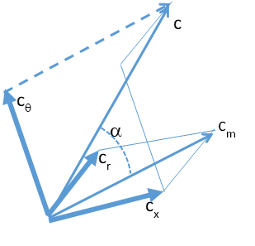

1. SFEE: $$q+w=\left(h_{2}-h_{1}\right)+\left(\frac{C_{2}^{2}}{2}-\frac{C_{1}^{2}}{2}\right)+g\left(z_{2}-z_{1}\right)$$

given that q is zero (adiabatic) and assuming further that the hydrostatic pressure change in the machine is negligible compared to the kinetic energy and enthalpy change:

$$w=\left(h_{2}-h_{1}\right)+\left(\frac{C_{2}^{2}}{2}-\frac{C_{1}^{2}}{2}\right)$$

since h0 = h + c2/2

since in a compressor h02 > h01, the sign assumes work input into the fluid, which means that the work at the shaft is negative, i.e. the outside world loses energy to do this.

1. Work at the shaft can only be from torque about the axis. Axial and radial velocity changes of the fluid do not affect the forces related to the torque about the axis. Therefore the work at the shaft is only related to tangential velocity change.
2. Thermodynamics is used to derive the work in a turbomachine from the first law in relation to energy changes. Fluid dynamics, related to the dynamics of the blades driving the fluid in a turbomachine, produces the work done by the shaft on the fluid via dynamic considerations. The work from first law is equal to the dynamic fluid work.
3. Rothalpy, *I*, is rotational enthalpy and is derived as follows with respect to the relative velocity of the fluid to the blades, c is absolute fluid velocity, and w is relative to impeller:
$$I=h_{0}-Uc_{θ}$$

$$h_{0}=h+\frac{1}{2}c^{2}$$

$$c^{2}=c_{x}^{2}+c_{θ}^{2}+c_{r}^{2}=w_{x}^{2}+{\left(w_{θ}+U\right)}^{2}+w_{r}^{2}=2Uw_{θ}+U^{2}+w^{2}$$

$$I=h+\frac{1}{2}\left(2Uw_{θ}+U^{2}+w^{2}\right)-U\left(U+w_{θ}\right)=h+\frac{1}{2}w^{2}-\frac{1}{2}U^{2}=h_{0,rel}-\frac{1}{2}U^{2}$$

4. The Mach number is *M*=*c*/*a*, where *c* is the speed of the fluid and *a* is the speed of sound. In this case it is 250/623 = 0.40. The point at which compressibility starts to become significant is when *M* >0.3, and therefore this is compressible, weakly. For isentropic stagnation, the stagnation enthalpy will be:

$$h_{0}=h+\frac{1}{2}c^{2}$$

The enthalpy of steam at 20 bar and 400°C is 3246 *kJ/kg*. Therefore, remembering that the kinetic term will have units of *J/kg*:

$$h_{0}=3,246,000+\frac{1}{2}{250}^{2}=3277 kJ/kg$$

1. Firstly, obtain the speed of sound in air at 315 *K* using *a* = √γR*T = √1.4*287*315 = 356 m/s.*

M = 250/356 = 0.7, which is just transonic.

For the mass flow, use the formula in the notes, and need the stagnation temperature, *T0*:

1. For weakly compressible flows, up to Mach 1, prior to a strong shock wave, the flow is isentropic because there is no heat transfer in the flow and there are no strong irreversible effects due to viscosity. Where there is a shock, the friction effects caused across the shock, which lead to a rise in static pressure, are due to friction, so although adiabatic, they are not reversible due to friction.
2. BWR and PWR are used (information in slides only), which rely on raising steam directly from the reactor core for the turbines or on having a high pressure water cycle around the core which passes heat to a second water/steam cycle for the turbines.
3. Moderation implies the slowing down of neutrons (information on slides) from nuclear reactions to thermal speeds to enable the next fission reactions to occur.

Axial flow turbomachines – the answers to text questions are available in the notes text. The purpose is to be a learning aid and to highlight important areas and calculation techniques.

1. Briefly explain why the rotor in a compressor stage has relative velocity, but the stator does not.
2. In a compressor stage, what are the consequences for the gas state from the work done by the shaft of the machine?
3. Define deviation angle in a compressor stage.
4. Why is camber angle significant for compressor blades and compressible flow?
5. What is the significance of camber angle for the relative velocity at entry to a blade row?
6. State one good and one bad effect of having a high space-chord ratio.
7. Sketch the velocity triangles for a compressor stage.
8. Briefly explain why the absolute exit flow angle determines work on a rotor.
9. Briefly explain why a thin low camber blade is used for compressors and a thicker higher camber blade works in the turbine.
10. Why is the de Haller limit (c2/c1<0.72) necessary for compressor stages?
11. Why is Carter’s rule for deviation angle useful for consideration of compressor design?
12. Briefly explain why stage loading can be much higher in turbines than in compressors.
13. Explain the usefulness of Zweifel’s criterion:
$$\frac{s}{b}=\frac{0.4}{\cos^{2}α_{2}\left(tanα_{1}+tanα_{2}\right)}$$

14. Sketch the combined velocity triangles for zero reaction and 50% reaction turbine stage. Explain the advantages and disadvantages of each.
15. A turbine stage is to be designed with a flow coefficient of 0.7, a reaction of 50% and a stage loading of 4.6. Find the entry and exit relative flow angles and sketch the velocity triangles; calculate the axial velocity and given that the speed is 5000 rpm **and the mean radius is 0.15 m (necessary additional information to question in notes)**, calculate the swirl angle.
16. Given the stagnation conditions at exit are 1400K and 3 bar with γ=1.4 and R=287 J/kgK, and that the mean radius is 0.15m, and blade height 0.01m, determine the static temperature and pressure at nozzle exit, and the mass flow rate.
17. An obvious consequence of the blade being driven with the tangential velocity of the turbomachine, and the fluid arriving with a different absolute velocity than the blade means there will be a relative velocity to define. In the case of the stator, the blade is stationary and therefore the velocity of the fluid relative to the blade is its absolute velocity.
18. The compressor stage does work on the gas. The direct consequence of this is raising the pressure and the temperature of the gas. The density increases, and the relative velocity with respect to the blades will slow down; the absolute velocity however speeds up due to being impelled by the compressor blades.
19. The absolute angle, *α*, of the velocity at entry or exit, is the angle made between the absolute velocity vector and the reference direction, which is the axis direction. The relative angle, *β*, of the velocity at entry or exit, is the angle made between the velocity relative to the blade and the reference direction. Finally, the angle of camber, *α’*, of the blade at entry or exit, is the angle made between the camber line at entry or exit. The deviation angle, *δ*, defines the angle by which the fluid has not turned as much as the exit camber angle, which is the difference between *β* and *α’* at exit.
$$δ=β-α'$$

20. Camber angle, *θ* in Fig 5 of the notes, which is the difference in camber angle, *α’*, between the nose and tail of the aerofoil, determines convexity of the aerofoil and therefore increased *θ* increases the strength the suction on the convex (i.e. *suction*) side of the aerofoil, and therefore increases risk of separation of the flow from the suction side, much like the stall of an aeroplane wing. In the case of compressible flow into the compressor (i.e. weakly compressible or transonic), it is likely that the acceleration of the flow over the suction side and the growth of the boundary layer as the pressure increases will lead to a shock or choked flow, leading to sudden static pressure increase and corresponding increase in boundary layer thickness and hence friction and a less efficient compression process.
21. As camber angle increases, the sensitivity to stalling the flow over the blade will increase, and a more restricted range of speed will be possible. The stagger angle, defines the angle of attack of the blade to the flow for a particular speed, and therefore controls this effect to some extent.
22. High s/l implies shorter blades – therefore lower friction on surfaces and therefore lower viscous losses and better efficiency of each individual aerofoil (this point not directly stated in the notes). For high s/l, there will be more velocity diffusion (i.e. the wake deviating increasingly from the blade exit angle between blades, seen in section 5b)i, point 3), meaning that the flow isn’t turned as far as desired and that the aerofoil is less efficient. Since the exit angle significantly affects the work (section 5b), an increased deviation angle will reduce the work done.
23. A compressor stage consists of a rotor followed by a stator. At entry to the rotor, there is a relative velocity and an absolute velocity which are usually not in line with the reference direction, and the absolute velocity vector minus the blade velocity vector, U, produces the relative velocity vector. At exit from the rotor, the absolute velocity will have enhanced circumferential component, again subtract the blade velocity to get the relative velocity, which should be approximately in the direction of the exit camber angle, with a small amount of deviation angle (i.e. deviating slightly to the right of the line extending in the trailing edge camber direction). The situation in the subsequent stator stage is simpler, since there is no blade velocity and only absolute velocity is considered. The entry velocity should be in line with the entry camber angle, and the exit velocity should be approximately in line with the exit camber angle, allowing a small deviation angle. The sketch alone is sufficient to answer the question, this explanation is given to explain why it should be constructed in that way. The velocity triangles are therefore approximately as shown as taken from the notes:

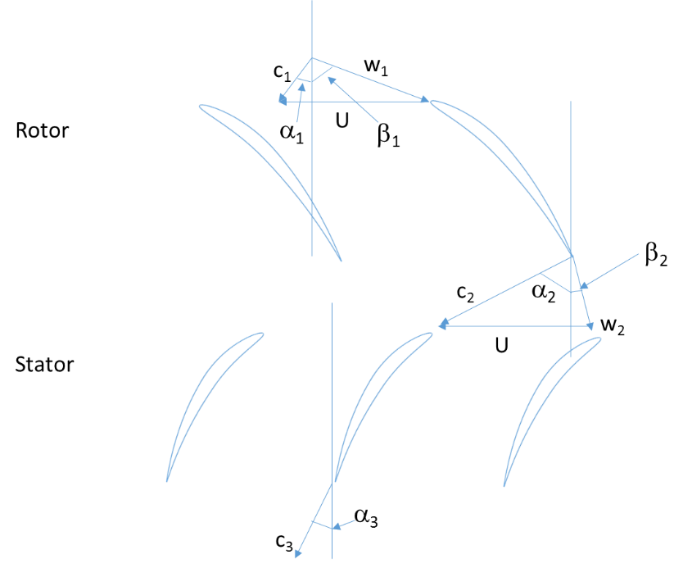

1. The work of a rotor is determined by the Euler work equation (see section 5b) which uses cθ, the tangential velocity. Since the tangential velocity is defined by the total velocity size and the angle at which it leaves the rotor blade, cθ = c sin α, the angle for axial flow machine defines the work done.
2. The compressor cannot tolerate high turning or the suction side of the blade will have flow separation, therefore camber is small (consequence of 5b)i point 2). The boundary layer thickens as the flow is compressed (consequence of 5b)i point 5), and therefore the flow passage should be as large as possible, hence thin blades to enhance. For a turbine, the blade must be strong, hence thick (section 5c). The flow is inherently more stable than the compressing flow due to the expansion and acceleration, therefore high turning is possible an a high camber and high turning will enhance work output due to higher flow turning, which is related to work done and loading per stage, which in turn is related to the need for a thick, strong blade.
3. De Haller limit recognises the limit appropriate due to the problem of overloading a compressor stage due to separation and choking, which is reflected in the compression ratio across the stage, determined by the velocity decrease as the density increases.
4. Carter’s rule is used to estimate deviation angle, which represents how much less than the blade angle the flow is turned and hence the effectiveness of the blade length to spacing. It allows an early estimation of deviation based on the blade geometry design and is therefore an aid to initial enhancement of the design.
5. The limitation of stage loading in compressors due to the density and boundary layer increase lead to separation and shock limiting, which are not seen in turbine stages because the flow expands and makes the boundary layer increasingly stable, pushing the flow to stay in contact with the blade.
6. Zwefel’s criterion defines the initial blade spacing to axial chord length ratio according to the desired flow angles in a stage. For high turning angles (change from α1 to α2), blades are close and for low turning angles (e.g. in the case of faster flow which reduces α) they can be further apart.
7. See Figure 9, caption especially, as reproduced here.

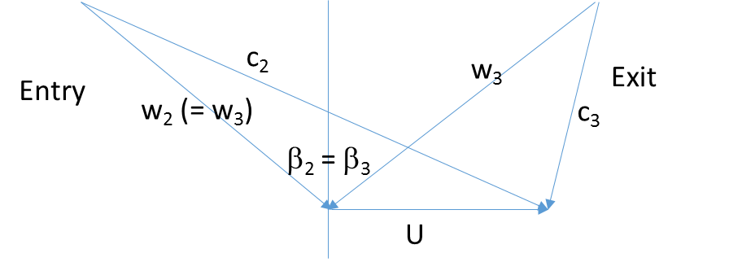

zero reaction, indicated by relative velocity angles being equal, and a high turning angle, has high stage loading, highly cambered blades – and separation risk

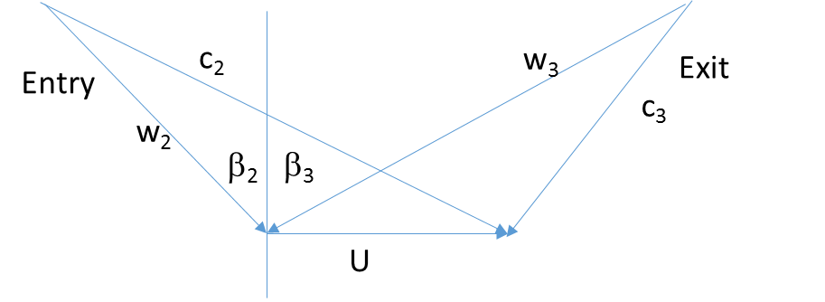

50% reaction, indicated by relative velocity at entry and absolute velocity at exit having equal magnitude and equal opposite directions, produces subsonic Mach numbers, and less loading per stage and therefore increased number of stages required.

1. Sketch of the velocity triangles to help the progression of ideas, (notice c – U = w):



Assume that the formulae for a repeating stage turbine can be used, in which it is assumed that cx is constant, and we can use the simplified formulae, as given in the formula sheet as follows:

Flow coefficient: $ϕ=\frac{c_{x}}{U}=0.7$

Reaction: $R=0.5=\frac{ϕ}{2}\left(\tan{β_{3}-\tan{β_{2}}}\right)$

Stage loading coefficient: $ψ=4.6=ϕ\left(\tan{β_{3}+\tan{β_{2}}}\right)$

Putting in the numbers given and rearranging produces β3 = 76.0° and β2 = 68.7°

Blade speed is required to work out the axial velocity cx, which is:

$$U=2π\frac{5000}{60}×0.15=78.5 m/s$$

Therefore cx = 0.7×78.5 = 54.9 m/s

Swirl angle is the angle of the absolute velocity to the reference direction (axis). Referring to the diagram of velocity triangle, c2θ = U + w2θ and swirl angle is the angle between c2 and the axis, and cx is known:

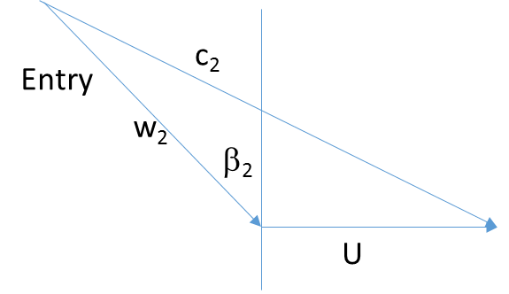

w2θ

to find w2, use the axial component, which is equal to cx:

Therefore with β2 = 68.7° from above, w2 = 151.1 m/s, and w2θ = 140.8 m/s. Therefore:

c2θ = 78.5 + 140.8 = 219.3 m/s, and:

$$\tan{α=\frac{c_{2θ}}{c_{x}}=\frac{140.8}{54.9}}=2.56→α=68.7°$$

Likewise for swirl at exit, α3:

**Note:** the result shows that the swirl angles are the same as the relative velocity angles, and this is expected for the symmetrical composite velocity triangle diagram for the 50% reaction turbine.

1. This question is slightly complicated by the question introduced by the stagnation conditions, indicating that compressibility might be an issue. Just need to eliminate that first. Calculate the static temperature by:

$$T=T_{0}-\frac{c^{2}}{2C_{p}}=1400-\frac{{151.8}^{2}}{2×1005}=1388 K$$

the cp value can be determined by eliminating from γ and R, or by stating prior knowledge for this condition. The temperature indicates not too different from stagnation therefore likely to be approximately non-compressible flow regime. Check the speed of sound and compare to velocity, c.

$$a=\sqrt{γRT}=746 m/s$$

Therefore M = 0.203, and we can consider that compressible effects are negligible since M < 0.3.

Static pressure can be determined by using Bernouilli approach for constant density, and density from gas law:

$$ρ=\frac{p}{RT}=\frac{300000}{287×1388}=0.75 kg/m^{3}$$

Therefore static pressure is:

$$p=p_{0}-\frac{1}{2}ρc^{2}=300000-\frac{1}{2}0.75×{151.8}^{2}=291 kPa$$

Mass flow rate is then simply a case of continuity:

$$\dot{m}=ρA_{n}c_{x}=0.75×2π×0.15×0.01×54.9=0.38 kg/s$$

If you check the error due to assuming incompressible, then you find a 2.7% error on density, which means that mass rate will be out by 0.01 kg/s. This demonstrates how compressibility becomes increasingly important with Mach number.